PHYSICS 1, CHAPTER 2
ADDITIONAL PROBLEMS

1. A 15.0-lb block rests on the floor.
(a) What force does the floor exert on the block?
(b) If a rope is tied to the block and run vertically over a pulley, and the other end is attached to a free-hanging 10.0-lb weight, what is the force exerted by the floor on the 15.0-lb block?
(c) If we replace the 10.0-lb weight in part (b) with a 20.0-lb weight, what is the force exerted by the floor on the 15.0-lb block?
ANSWER: (a) 15.0 lb up (b) 5.00 lb up (c) 0
2. The distance between two telephone poles is 50.0 m. When a 1.00-kg bird lands on the telephone wire midway between the poles, the wire sags 0.200 m. Draw a free-body diagram of the bird. How much tension does the bird produce in the wire? Ignore the weight of the wire.
ANSWER: 613 N
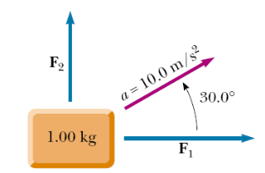
3. A 1.00-kg mass is observed to accelerate at 10.0 m/s² in
a direction 30.0° north of east (Fig). The force F₂ acting on the mass has a magnitude of 5.00 N and is directed north. Determine the magnitude and direction of the force F₁ acting on the mass.
ANSWER: 8.66 N east

4. Two people pull as hard as they can on ropes attached to a boat that has a mass of 200 kg. If they pull in the same direction, the boat has an acceleration of 1.52 m/s² to the right. If they
pull in opposite directions, the boat has an acceleration of 0.518 m/s² to the left. What is the force exerted by each person on the boat? (Disregard any other forces on the boat.)
ANSWER: 100 N and 204 N
5. A block is given an initial velocity of 5.00 m/s up a frictionless 20.0° incline. How far up the incline does the block slide before coming to rest?
ANSWER: 3.73 m
6. A 3.00-kg block starts from rest at the top of a 30.0° incline and slides a distance of 2.00 m down the incline in 1.50 s. Find
(a) the magnitude of the acceleration of the block,
(b) the coefficient of kinetic friction between block and plane,
(c) the frictional force acting on the block, and
(d) the speed of the block after it has slid 2.00 m.
ANSWER: (a) 1.78 m/s² (b) 0.368 (c) 9.37 N (d) 2.67 m/s
7. A boy drags his 60.0-N sled at constant speed up a 15.0° hill. He does so by pulling with a 25.0-N force on a rope attached to the sled. If the rope is inclined at 35.0° to the horizontal,
(a) what is the coefficient of kinetic friction between sled and snow?
(b) At the top of the hill, he jumps on the sled and slides down the hill. What is the magnitude of his acceleration down the slope?
ANSWER: (a) 0.161 (b) 1.01 m/s²
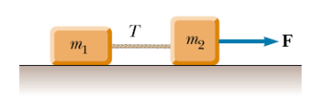
8. Two blocks connected by a rope of negligible mass are being dragged by a horizontal force F (see Fig.). Suppose that F = 68.0 N, m₁ = 12.0 kg, m₂ = 18.0 kg, and the coefficient of kinetic friction between each block and the surface is 0.100.
(a) Draw a free-body diagram for each block.
(b) Determine the tension T and the magnitude of the acceleration of the system.
ANSWER: (b) 27.2 N, 1.29 m/s²

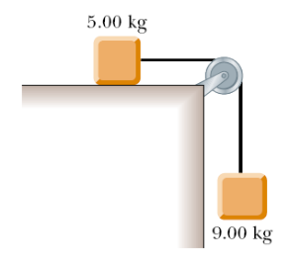
9. A 9.00-kg hanging weight is connected by a string over a pulley to a 5.00-kg block that is sliding on a flat table (Fig). If the coefficient of kinetic friction is 0.200, find the tension in the string.
ANSWER: 37.8 N
10. A light string can support a stationary hanging load of 25.0 kg before breaking. A 3.00-kg mass attached to the string rotates on a horizontal, frictionless table in a circle of radius 0.800 m. What range of speeds can the mass have before the string breaks?
ANSWER: Any speed up to 8.08 m/s
11. A coin placed 30.0 cm from the center of a rotating, horizontal turntable slips when its speed is 50.0 cm/s.
(a) What provides the force in the radial direction when the coin is stationary relative to the turntable?
(b) What is the coefficient of static friction between coin and turntable?
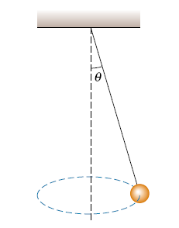
ANSWER: (a) static friction (b) 0.085
12. Consider a conical pendulum with an 80.0-kg bob on a 10.0-m wire making an angle of θ = 5.00° with the vertical (Fig). Determine
(a) the horizontal and vertical components of the force exerted by the wire on the
pendulum and
(b) the radial acceleration of the bob.
ANSWER: (a) 68.6 N toward the center of the circle and 784 N up (b) 0.857 m/s²
13. A 40.0-kg child sits in a swing supported by two chains, each 3.00 m long. If the tension in each chain at the lowest point is 350 N, find
(a) the child’s speed at the lowest point and
(b) the force exerted by the seat on the child at the lowest point. (Neglect the mass of the seat.)
ANSWER: (a) 4.81 m/s (b) 700 N up

14. A merry-go-round makes one complete revolution in 12.0 s. If a 45.0-kg child sits on the horizontal floor of the merry-go-round 3.00 m from the center, find
(a) the child’s acceleration and
(b) the horizontal force of friction that acts on the child.
(c) What minimum coefficient of static friction is necessary to keep the child from slipping?
ANSWER: (a) 0.822 m/s2 (b) 37.0 N (c) 0.0839
15. A person stands on a scale in an elevator. As the elevator starts, the scale has a constant reading of 591 N. As the elevator later stops, the scale reading is 391 N. Assume the magnitude of the acceleration is the same during starting and stopping, and determine
(a) the weight of the person,
(b) the person’s mass, and
(c) the acceleration of the elevator.
ANSWER: (a) 491 N (b) 50.1 kg (c) 2.00 m/s²
16. A curve in a road forms part of a horizontal circle. As a car goes around it at constant speed 14.0 m/s, the total force exerted on the driver has magnitude 130 N. What are the magnitude and direction of the total force exerted on the driver if the speed is 18.0 m/s instead?
ANSWER: 215 N horizontally inward

